1. What is SQL:

=> SQL stands for Structured Query Language. It is a language that is used to perform any operation in RDBMS. It provides pre-defined syntax of queries that is used for transactions in Database. So SQL queries are used to store, manipulate and retrieve any part of data in RDBMS.

1. What is Database

=> A database is a systematic collection of data. They support electronic storage and manipulation of data. Databases make data management easy.

1. Write down syntax to create a database

Create database database_name;

1. Write down syntax to create a table in any database

Syntax to create Tables:

Create table table_name ( Column_name data_type(size), . . Column_name data_type(size), )

1. What do you understand by server

Ans: SERVER IS A COMPUTER PROGRAM DEVICE THAT PROVIDE A SERVER ANOTHER computer program it is users also knows as the client

1. What is difference between DBMS and RDBMS

=>Ans:DBMS stands for database management system. It provides concept to store and manage data for future use.in dbms data can be managed in many format like file formate, table formate, json format,key value format .

=>RDBMS: RDBMS stands for relation database . management system.data is stored in form of table ROW and COLUMNS.

1. Write down syntax to update any two column value all records

Ans:

Update table_name set column_name=value,column_name=value where <Condition>

1. What is difference between alter and update command

Ans :-

Alter:

1: ALTER command is a Data Definition Language Command.

2: ALTER TABLE table_name ADD column_name datatype;

3: ALTER Command by default initializes values of all the tuple as NULL.

4:ALTER Command operates on the attribute of a relation.

UPDATE:

1: UPDATE command is a Data Manipulation Language Command.

2: UPDATE Command modifies one or more records in the relations

3: UPDATE table_name SET column_name1 = value, column_name2 = value, ...

4: Update Command operates on the attribute value of a specific tuple in a relation

1. What is different types of SQL queries.

Ans:-

UPDATE-

ALTER-

DROP-

SELECT-

ROLLBACK-

SAVEPOINT

COMMIT ETC-

1. Write down all commands that comes under DDL, DML DCL and TCL

Ans: DDL (Data definition languge)

* 1. Create
  2. Alter
  3. Drop
  4. Truncate

DML (Data Manipulation Language)

* 1. Insert
  2. Delete
  3. Update
  4. Select

DCL(Data Control Language)

* 1. Grant
  2. Revoke
  3. rename

TCL(Transaction Control Language)

* 1. Commit
  2. Rollback
  3. Savepoint

1. Write down query to create schema of student table as given below :

|  |  |
| --- | --- |
| SR | INT , AUTO INCREMENT |
| NAME | NOT ACCEPTS NULL VALUES |
| MOBNO |  |
| EMAIL_ID | ONLY ACCEPTS UNIQUE VALUE |
| COURSE |  |
| BRANCH |  |
| YEAR |  |
| TOTAL_FEE | ONLY ACCEPTS VALUE WITHIN 0 TO 20000 |
| REG_DATE |  |
|  |  |
|  |  |

Code of table:

create table student

(

SR int identity (1,1),

NAME varchar not null,

MOBNO bigint,

EMAIL_ID varchar(50) primary key,

COURSE varchar(40),

BRANCH varchar(30),

YEAR varchar(20),

TOTAL_FEE money,

REG_DATE date

);

1. Insert as given rows in student table :

|  |  |  |  |  |  |  |  |  |
| --- | --- | --- | --- | --- | --- | --- | --- | --- |
| SR | NAME | MOBNO | EMAIL_ID | COURSE | BRANCH | YEAR | TOTAL_FEE | REG_DATE |
| 1 | SHIVAM SHARMA | 9887766556 | [shivam@gmail.com](mailto:shivam@gmail.com) | B.Tech | C.S | First | 12000 | 2022-10-20 |
| 2 | SHIVAM SINGH | NULL | [shivam10singh@gmail.com](mailto:shivam10singh@gmail.com) | B.Tech | I.T | First | 13000 | 2022-10-23 |
| 3 | SHIVANI YADAV | NULL | [01shivani@gmail.com](mailto:01shivani@gmail.com) | Diploma | C.S | First | 16000 | 2022-10-26 |
| 4 | RAVI VERMA | 6778877778 | [raviverma@gmail.com](mailto:raviverma@gmail.com) | Diploma | I.T | First | 15000 | 2022-09-23 |
| 5 | AMIT SINGH | 7887765545 | [amit@gmail.com](mailto:amit@gmail.com) | BCA | NULL | Second | 15000 | 2022-10-21 |
| 6 | POOJA | 9678565455 | [pooja123@gmail.com](mailto:pooja123@gmail.com) | BCA | NULL | Third | 16000 | 2022-10-28 |
| 7 | AYUSHI SINGH | NULL | [908ayushi@gmail.com](mailto:908ayushi@gmail.com) | Diploma | I.T | Second | 11000 | 2022-10-28 |
| 8 | VINAY SINGH | 8756453221 | [101vinay@gmail.com](mailto:101vinay@gmail.com) | B.Tech | C.S | Second | 18000 | 2022-10-23 |
| 9 | SANDEEP DUBEY | 9123300400 | [008sandeep@gmail.com](mailto:008sandeep@gmail.com) | BCA | NULL | Third | 18000 | 2022-09-28 |
| 10 | HIMANSHU RAI | 8100987660 | [678himanshu@gmail.com](mailto:678himanshu@gmail.com) | B.Tech | I.T | Third | 15000 | 2022-10-20 |

Code of this table:

insert into student values('SHIVAM SHARMA',9887766556,'shivam@gmail.com','B.Tech','C.S','First',

12000,'2022-10-20'),

('SHIVAM SINGH',NULL,'shivam10singh@gmail.com','B.Tech','I.T','First',13000

,'2022-10-23'),

('SHIVANI YADAV',NULL,'01shivani@gmail.com','Diploma','C.S','First',16000

,'2022-10-26'),

('RAVI VERMA',6778877778,'raviverma@gmail.com','Diploma','I.T',

'First',15000,'2022-10-23'),

('AMIT SINGH',7887765545,'amit@gmail.com','BCA','NULL','Second',15000,

'2022-10-21'),

('POOJA',9678565455,'pooja123@gmail.com','BCA','NULL',

'Third',16000,'2022-10-28'),

('AYUSHI SINGH',NULL,'908ayushi@gmail.com','Diploma','I.T','Second'

,11000,'2022-10-28'),

('VINAY SINGH',8756453221,'101vinay@gmail.com','B.Tech','C.S','Second',18000,

'2022-10-23'),

('SANDEEP DUBEY',9123300400,'008snadeep@gmail.com','BCA','NULL','Third',18000,'2022-10-28'),

('HIMANSHU RAI',8100987660,'678himanshu@gmail.com','B.Tech','I.T','Third',15000,'2022-10-20')

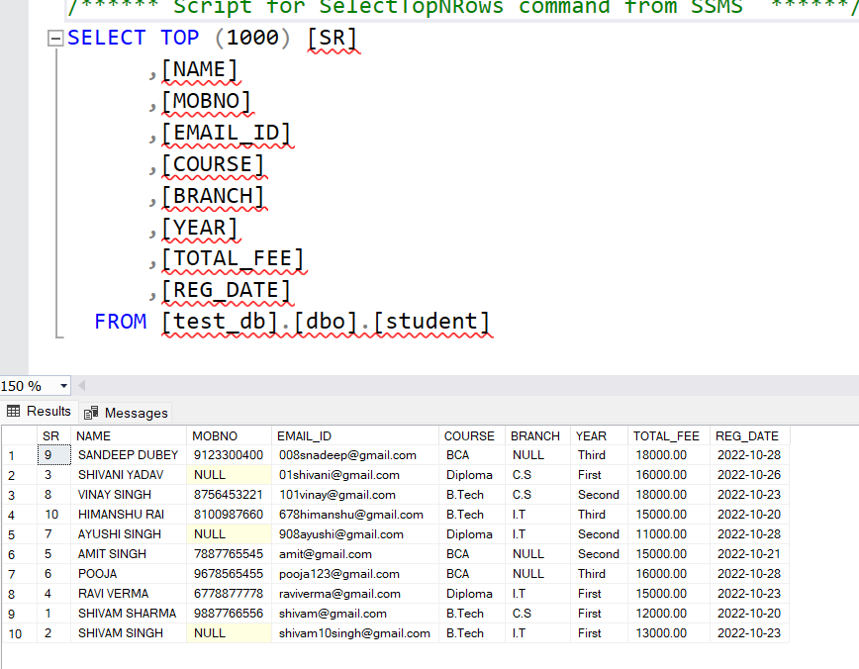

1. select all record of students stored in table

Ans: select * from student

1. select all record of student but in branch column show “Computer Science” for C.S Students and “Information Technology” For I.T students and “not found” where branch has null value

Ans: select *,case when branch='C.S' then 'Computer Science'

when Branch='I.T' THEN 'Information Technology' else'notfound' end from student ;

1. select only name,mobno,email_id of all students

Ans: select NAME,MOBNO,EMAIL_ID from student

1. select all students of first year and second year

Ans: select * from student where (year='First' or year='Second')

1. select all c.s and i.t students of first year and second year

Ans: select * from student where (year='First' or year='Second') and (branch='C.S' or Branch='I.T')

1. select all students records who joined within 2022-10-20 to 2022-10-25
2. select all student record whose mobile number is not found

Ans: select * from student where MOBNO='Null'

1. select name, mobno, course, branch, year of those students whose name starts from shivam

Ans: select name,mobno,course,branch,year from student where Name LIKE '%Shivam%' ;

1. select name, mobno, course, branch, year of those students whose name starts with s to z
2. select average fee of c.s students
3. select all record of students whose fee is highest in table
4. select all record of student whose fee is second highest in table
5. Create a fee_payment table as given below :

Code :

create table fee_payment(

Pay_id int identity(101,1),

userid varchar(50) primary key not null,

amount money,

mode varchar(15),

date date

);

|  |  |
| --- | --- |
| Pay_id | INT , AUTO INCREMENT |
| userid | NOT NULL |
| amount | money |
| mode |  |
| date |  |
|  |  |

1. Insert below given rows in fee_payment table

Code:

insert into fee_payment values('shivam@gmail.com',5000,'ÇASH','2022-10-23'),

('amit@gmail.com',3000,'GPAY','2022-10-23'),

('shivam@gmail.com',7000,'PAYTM','2022-10-28'),

('raviverma@gmail.com',5000,'ÇASH','2022-09-23'),

('raviverma@gmail.com',4000,'ÇASH','2022-10-21'),

('amit@gmail.com',7000,'PAYTM','2022-10-28'),

('101vinay@gmail.com',4000,'PAYTM','2022-10-28')

Screenshot:

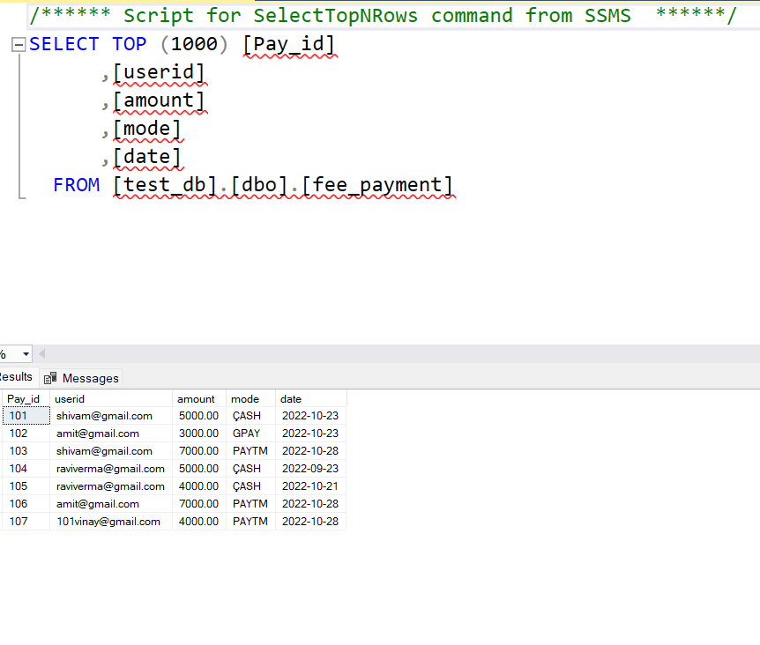

|  |  |  |  |  |
| --- | --- | --- | --- | --- |
| Pay_id | userid | amount | mode | date |
| 101 | [shivam@gmail.com](mailto:shivam@gmail.com) | 5000 | CASH | 2022-10-23 |
| 102 | [amit@gmail.com](mailto:amit@gmail.com) | 3000 | GPAY | 2022-10-23 |
| 103 | [shivam@gmail.com](mailto:shivam@gmail.com) | 7000 | PAYTM | 2022-10-28 |
| 104 | [raviverma@gmail.com](mailto:raviverma@gmail.com) | 5000 | CASH | 2022-09-23 |
| 105 | [raviverma@gmail.com](mailto:raviverma@gmail.com) | 4000 | CASH | 2022-10-21 |
| 106 | [amit@gmail.com](mailto:amit@gmail.com) | 7000 | PAYTM | 2022-10-28 |
| 107 | [101vinay@gmail.com](mailto:101vinay@gmail.com) | 4000 | PAYTM | 2022-10-28 |

1. Select total fee paid of all students

Ans: select sum(amount) as total_paid_amount from FEE_PAYMENT

1. Select total paid fee of all students who have paid more than 6000

Ans:select AMOUNT from FEE_PAYMENT where amount>6000

1. select all payments with student name, mobile_no, course, branch, year, email_id, amount, mode, date

Ans: select student.NAME,student.MOBNO,student.COURSE,student.BRANCH,student.YEAR,student.EMAIL_ID

,fee_payment.amount,

fee_payment.mode,fee_payment.date from student left join fee_payment on

fee_payment.userid=student.EMAIL_ID

1. select total payment paid in cash mode in October month.
2. Select mode , all paid amount in this mode

Ans: select sum(amount) as paid_amount,mode from FEE_PAYMENT group by mode

1. Select total paid amount in every date

Ans: select sum(amount),date from FEE_PAYMENT group by date

1. Select total paid amount in every date within 2022-10-20 to 2022-10-25

Ans: select sum(amount),date from fee_payment group by date

1. update BCA course to “Branch of Computer Application” of all student

ANS: update student set course='Branch of computer science ' where sr=5 or sr=6 or sr=9

1. update mobile number of student to 1000000000 where mobile number is null

Ans: update student set MOBNO=100000000 where MOBNO is nulL

1. select all student record with name, mobile number, email id , total fee and paid fee
2. select min total fee present in student table

Ans : select min(total_fee) as minimum_fee from student

1. select student record with minimum total fee
2. create a result table with below given schema

Code:

create table result

(

SR int identity(1,1),

USERID varchar(70),

TOTAL_MARKS int,

OBTAIN_MARKS int,

year varchar(10),

Result_date date

);

|  |  |
| --- | --- |
| SR | int, auto increment |
| USERID | string |
| TOTAL_MARKS | int |
| OBTAIN_MARKS | int |
| Year | string |
| Result_date | date |

1. Insert below given records to the result table

Code:

insert into result values('amit@mail.com',1000,800,'First','2022-12-23');

insert into result values('pooja@mail.com',1000,700,'second','2022-12-26');

insert into result values('908ayush@mail.com',1000,400,'First','2022-12-23');

insert into result values('101vinay@mail.com',1000,789,'First','2022-12-23');

insert into result values('008sandeep@mail.com',1000,456,'Second','2022-12-26');

insert into result values('678himanshu@mail.com',1000,786,'Second','2022-12-26');

|  |  |  |  |  |  |
| --- | --- | --- | --- | --- | --- |
| SR | USERID | TOTAL_MARKS | OBTAIN_MARKS | Year | Result_date |
| 1 | [amit@gmail.com](mailto:amit@gmail.com) | 1000 | 800 | First | 2022-12-23 |
| 2 | [pooja123@gmail.com](mailto:pooja123@gmail.com) | 1000 | 700 | Second | 2022-12-26 |
| 3 | [908ayushi@gmail.com](mailto:908ayushi@gmail.com) | 1000 | 400 | First | 2022-12-23 |
| 4 | [101vinay@gmail.com](mailto:101vinay@gmail.com) | 1000 | 789 | First | 2022-12-23 |
| 5 | [008sandeep@gmail.com](mailto:008sandeep@gmail.com) | 1000 | 456 | Second | 2022-12-26 |
| 6 | [678himanshu@gmail.com](mailto:678himanshu@gmail.com) | 1000 | 786 | Second | 2022-12-26 |

1. Select userid,all total_marks and total obtain_marks of every students

Ans: SELECT USERID,TOTAL_MARKS,OBTAIN_MARKS from result

1. Select all records of result table with student name, mob_no , email_id .
2. select all result records in order of result_date with serial number
3. select sr, userid, total_marks , obtain_marks , percentages , year , result_date of every students
4. select name, mobile_no , course, branch, year, total , obtain marks of all students
5. select first year student name, mobile_number, emailid , total_marks, obtain_marks who got minimum marks
6. update result date of all first year 2022-12-25 and result date of all second year student 2022-12-30
7. update obtain_marks of amit to 850

Ans: update result set obtain_marks=850 where sr=1

1. select all student’s result in order of obtain marks
2. select student email id who obtain maximum marks